Linux Commands I have learnt

1. **Top – shows system usage**

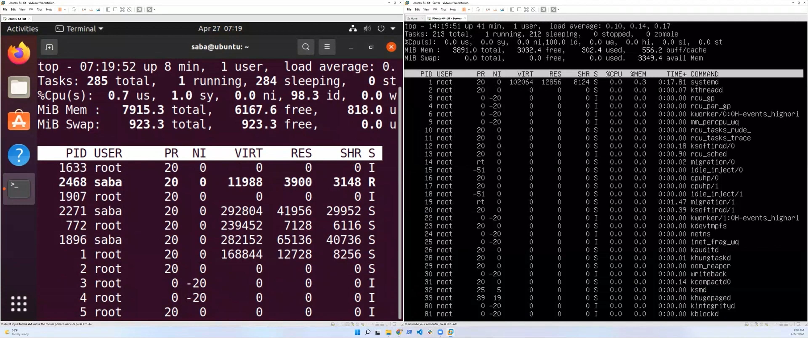

On the server, system usage is low,

1. Ip address – check machines ip address

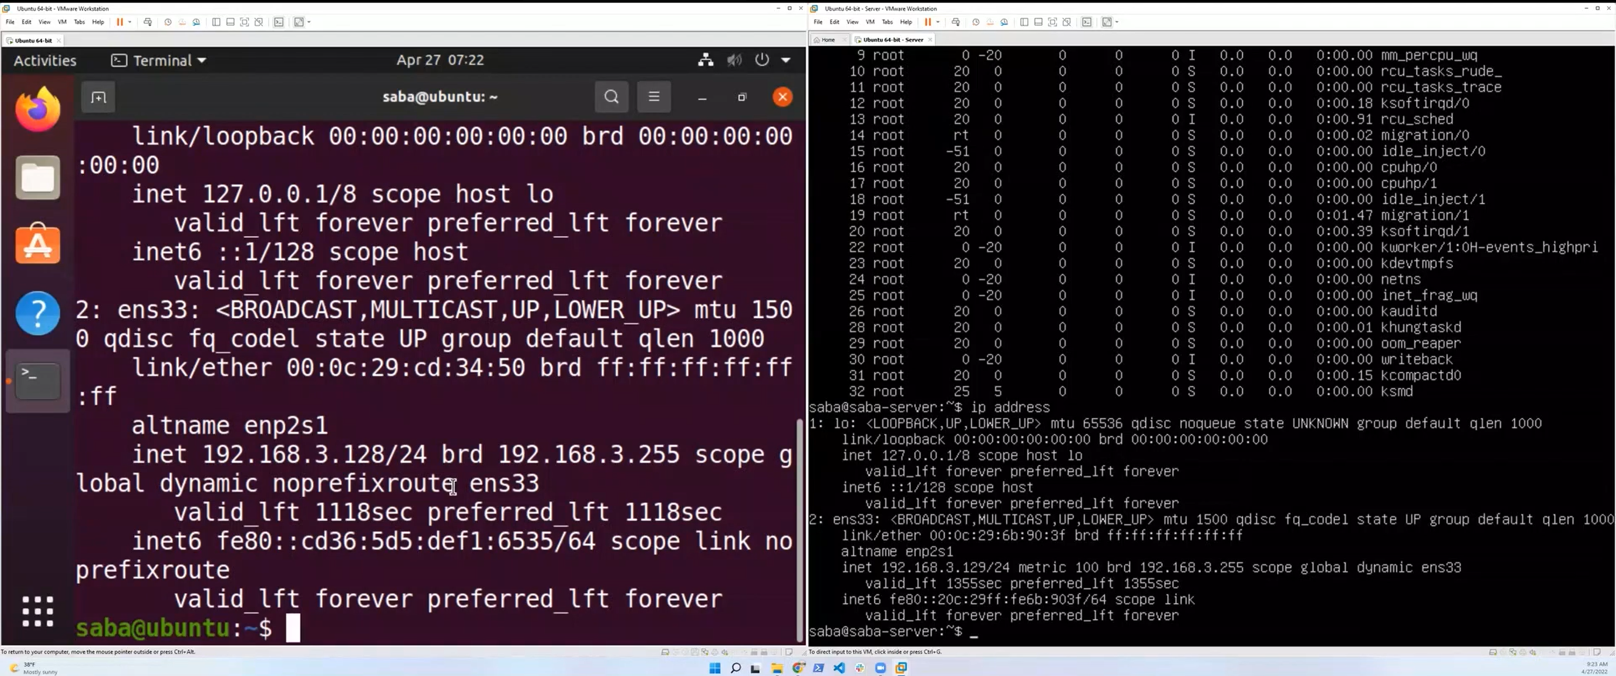

1. 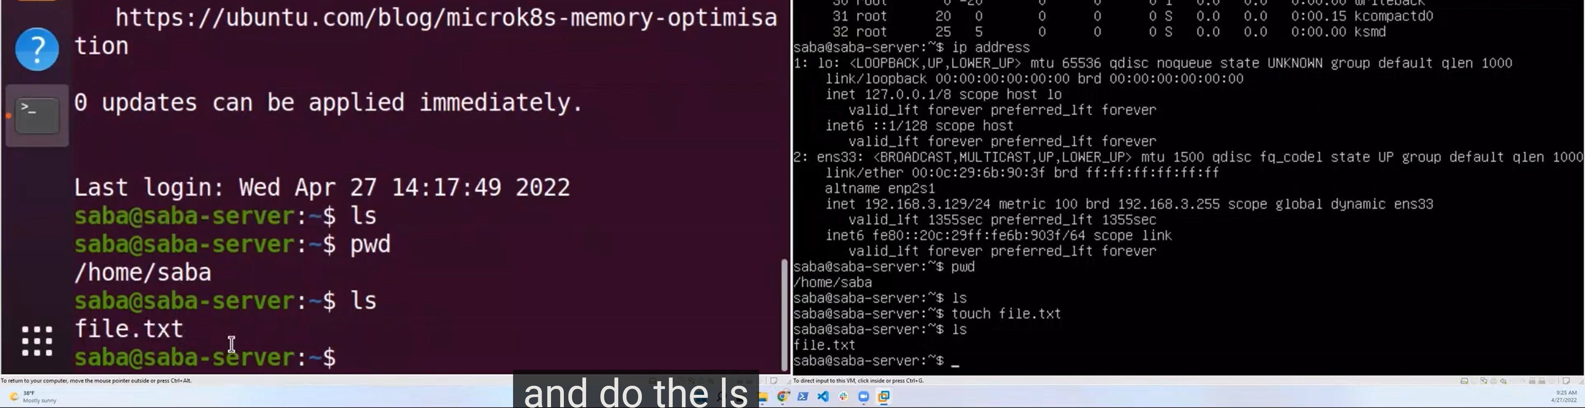**Touch file.txt – this create a file named file.txt**
2. Echo – to add content to a file
3. Cat command used to display content within a file

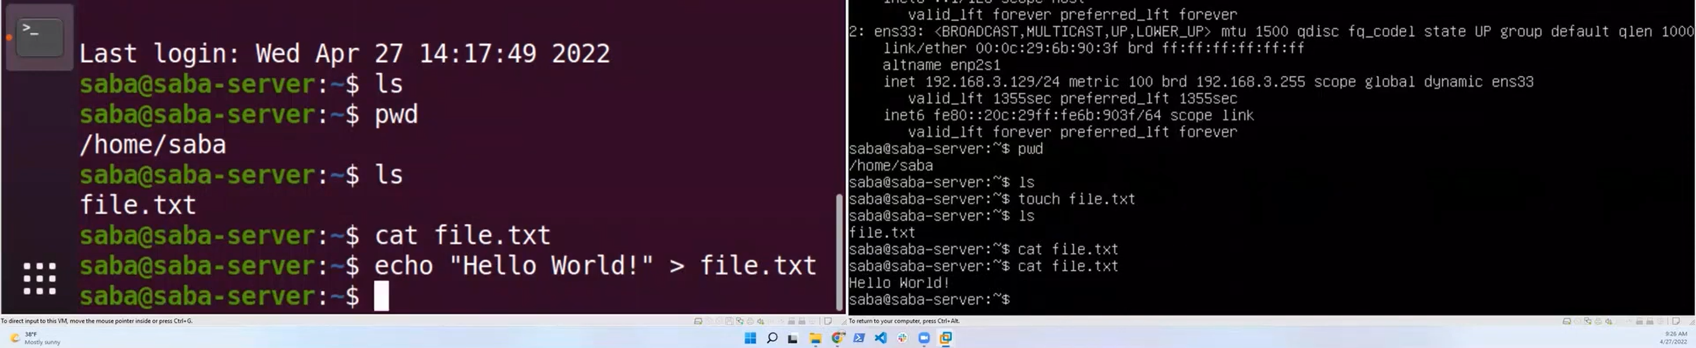

EDX Linunx – Chapter 4 – GUI

* **If the display manager is not started by default in the default runlevel**, you can start the graphical desktop different way:
  + after **logging on to a text-mode console**, by **running startx from the command line**. Or, you can start the display manager (gdm, lightdm, kdm, xdm, etc.) manually from the command line.
  + This differs from running startx as the display managers will project a sign in screen. We discuss them next.

**gnome-tweaks**

* **setting options.**
  + It also permits you to easily install extensions by external parties. Not all Linux distributions install this tool by default, but it is always available (older distributions used the name gnome-tweak-tool).
  + **You may have to run it by hitting Alt-F2 and then typing in the name. You may want to add it to your Favorites list as we shall discuss.**

**Viewing Files**

The File Manager allows you to view files and directories in more than one way.

**You can switch between the Icons and List formats, either by clicking the familiar icons in the top bar, or you can press CTRL-1 or CTRL-2 respectively.**

In addition, you can also **arrange the files and directories by name, size, type, or modification date** for further sorting. To do so, **click View and select Arrange Items**.

Another useful option is to **show hidden files** (sometimes imprecisely called system files), which are usually configuration files that are hidden by default and whose name starts with a dot. **To show hidden files, select Show Hidden Files from the menu or press CTRL-H.**

**Chapter 5: System Configuration from the Graphical Interface**

**/System, Display, Date and Time Settings**

NOTE: You can also ascertain your current resolution by typing at the command line:

**student:/tmp> $ xdpyinfo | grep dim**

**dimensions: 3200x1080 pixels (847x286 millimeters)**

**# # # # # # # # # # #**

1. ls (list)

Use **ls** to see inside the directory /usr/share/doc/.

Each one of the directories you see includes READMEs, examples, changelog, and more for their respective programs.

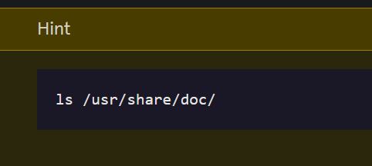

1. 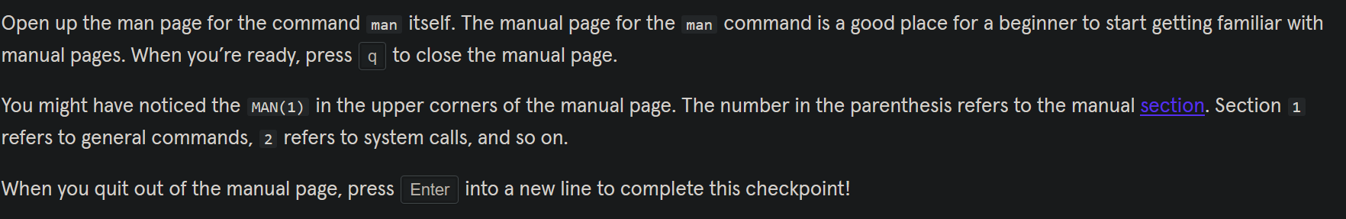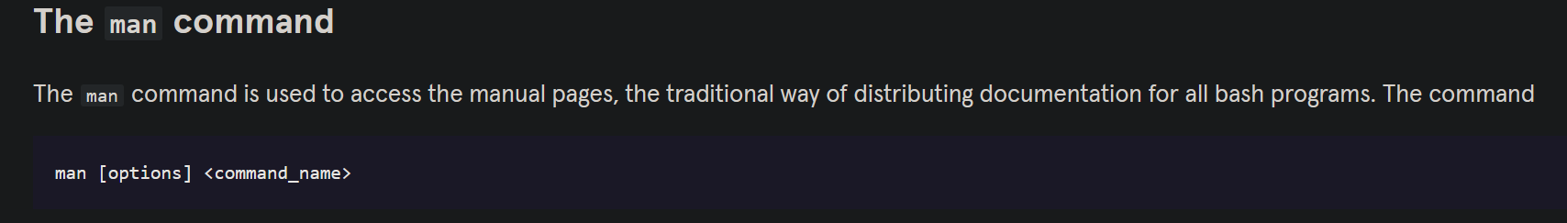**man** (manual) **-** used to view documentation.

[**https://en.wikipedia.org/wiki/Man_page#Manual_sections**](https://en.wikipedia.org/wiki/Man_page#Manual_sections)

1. **info** (information)

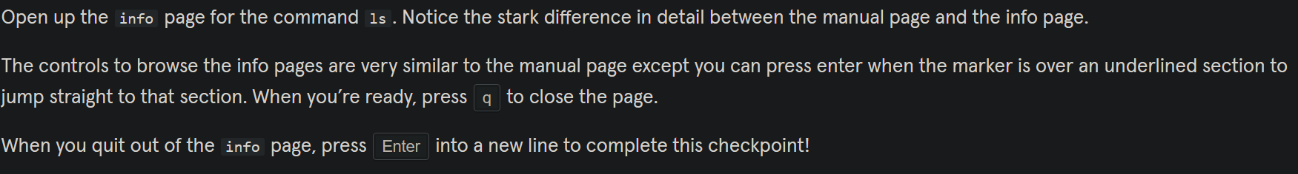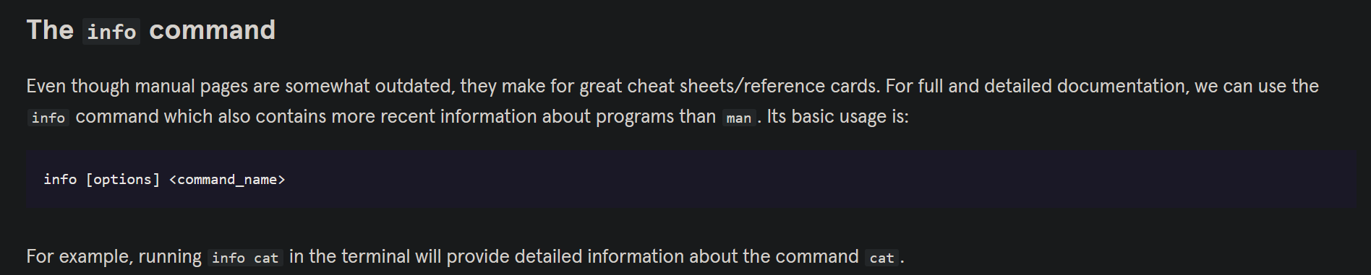

1. **date** - see the current date printed out!
2. **ncal** (new calendar) – prints out current month’s calendar
3. **clear** – clear the terminal
4. **rm** – remove – to delete things
5. **cat**: used to type out a file (or combine files).
6. **head**: used to show the first few lines of a file.
7. **tail**: used to show the last few lines of a file.

**EDX: Chapter 7: Command Line Operations /Command-Line Mode Options**

16: **stop** the GUI desktop with the systemctl utility and most distributions will also work with the telinit command, as in:

**$ sudo systemctl stop gdm (or sudo telinit 3)**

and restart it (after logging into the console) with:

**$ sudo systemctl start gdm (or sudo telinit 5)**

On Ubuntu versions before 18.04 LTS, substitute **lightdm** for **gdm**.

On my usman virtual box sudo telinit 3 and sudo telinit 5 work

**Shutting down**

17. **reboot** – reboot machine

18. **halt** - take your computer down to the halt state but will not ask the hardware to power down.

19. **shutdown** – shutdown computer

For more information: <https://www.howtogeek.com/411925/how-to-reboot-or-shut-down-linux-using-the-command-line/>

20. which - one way to locate programs is to employ the which utility. For example, to find out exactly where the diff program resides on the filesystem:

**$ which diff**

**/usr/bin/diff**

21. whereis - If which does not find the program, whereis is a good alternative because it looks for packages in a broader range of system directories:

**$ whereis diff**

**diff: /usr/bin/diff /usr/share/man/man1/diff.1.gz /usr/share/man/man1p/diff.1p.gz**

as well as locating source and man files packaged with the program.

22. **echo $HOME**:

When you first log into a system or open a terminal, the default directory should be your home directory. You can print the exact path of this by typing echo $HOME. Many Linux distributions actually open new graphical terminals in $HOME/Desktop. The following commands are useful for directory navigation:

23: **Pwd** - Dsplays the present working directory

24. **cd** **~** or **cd**: Change to your home directory (shortcut name is ~ (tilde))

25. **cd ..** Change to parent directory (..)

26. **cd -** Change to previous directory (- (minus))

**Exploring the Filesystem**

27. **ls –a**  - List all files, including hidden files and directories (those whose name start with . )

28. **tree**  - Displays a tree view of the filesystem

29. **dirs** The list of directories is displayed with the dirs command.

**Viewing Files**

**Chapter 7: Command Line Operations / Working with Files**

30. **cat**: Used for viewing files that are not very long; it does not provide any scroll-back.

31. **tac**: Used to look at a file backwards, starting with the last line.

32. **less**: Used to view larger files because it is a paging program. It pauses at each screen full of text, provides scroll-back capabilities, and lets you search and navigate within the file.

NOTE: Use / to search for a pattern in the forward direction and ? for a pattern in the backward direction. An older program named more is still used, but has fewer capabilities: "less is more".

33. **tail**: Used to print the last 10 lines of a file by default. You can change the number of lines by doing -n 15 or just -15 if you wanted to look at the last 15 lines instead of the default

34. **head**: The opposite of tail; by default, it prints the first 10 lines of a file.

35. **touch** is often used to set or update the access, change, and modify times of files. By default, it resets a file's timestamp to match the current time.

However, you can also create an empty file using touch:

**$ touch <filename>**

This is normally done to create an empty file as a placeholder for a later purpose.

touch provides several useful options. For example, the -t option allows you to set the date and timestamp of the file to a specific value, as in:

**$ touch -t 12091600 myfile**

This sets the myfile file's timestamp to 4 p.m., December 9th (12 09 1600).

**Moving, Renaming or Removing a File**

|  |  |  |
| --- | --- | --- |
|  | **Command** | **Usage** |
| **36** | **mv** | Rename a file |
| **37** | **rm** | Remove a file |
| **38** | **rm –f** | Forcefully remove a file |
| **39** | **rm –i** | Interactively remove a file |

Note that **mv** does double duty, in that it can:

* Simply rename a file
* Move a file to another location, while possibly changing its name at the same time.

If you are not certain about removing files that match a pattern you supply, it is always good to run rm interactively (**rm –i**) to prompt before every removal.

EDX: Chapter 7 Renaming or Removing a Directory

40. **rmdir works only on empty directories; otherwise you get an error.**

41. **mv** Rename a directory

**42. rmdir Remove an empty directory**

**43. rm -rf Forcefully remove a directory recursively**